# Introduction

The project goal is to make a teaching aid for schools to help with incorporating micro:bits into computing lessons. While the small-sized micro:bit module is great for coding, teachers find it difficult to demonstrate student's work to the whole class. The aim is for the students to program their micro:bits individually and then in order to demonstrate their work, they plug their device into the mega:bit which then replicates the code on a larger scale for the whole class to see.

# Design History

In order to achieve the design requirements several possibilities were considered at the start.

## Software Design Choices

**Accessibility Pin**

Accessibility Pin One of the GPIO pins is a ‘reserved accessibility pin’, a possibility to run the larger LED matrix from this pin was considered.

**I2C**

Like the accessibility pin, the larger LED matrix could be controlled via the I2C bus. There were concerns with this idea and whether the important timing requirements of the I2C communication would interfere with that of the Bluetooth and RF radios. A solution to this issue would be to remove functionality for interrupts and force the user to write code linearly. This is not ideal as interrupts are a foundation to more complex code and an important learning point for students.

**Single Wire serial comms?**

**USB**

The USB port was also considered as an option that could provide two way communication to control the mega:bit or possibly to ‘clone’ the code from micro:bit onto the mega:bit.

## Hardware Design Choices

All the decisions regarding the structure of the product were followed after a thorough market research among teachers that use micro:bit in their classrooms. The results of the survey in which 50 teachers participated are shown below:

**Mega:bit Demand**

92.5% of the teachers are interested in having a Megabit, from which 60% would definitely love to have one and the rest 32.5% would take a decision based on the features. As a result, the rest of the survey examined the most desirable features for the teachers.

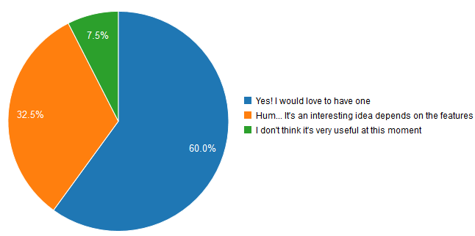

**Size**

Regarding the size, the Megabit is desired to be either the size of an A4 paper or bigger.

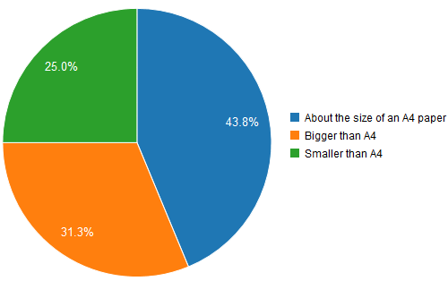

**Battery preference**

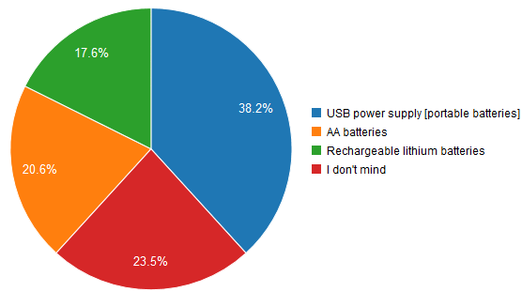

Other survey results showed that teachers did not find an additional LED screen or buttons at the back of the micro:bit useful. Because of this the mega:bit design was kept as close as possible to the micro:bit look to avoid confusions regarding each component functionalities.

**Power**

The micro:bit requires 3.3V to be powered via the edge connector, however, the LED driver requires 4.5-5.5V in order to work correctly.

A few ideas were considered in order to allow the batteries to power the circuit. We had initially begun designing based on 4xAA batteries (6V) being stepped down to 5V through a linear voltage regulator. However, it was soon made clear that there are multiple problems with this design

* Linear voltage regulators generally require ~2V above the desired output voltage to work correctly.
* If the batteries discharged below 5V, the output will always be below 5V.

A Buck converter was then considered, but this also suffered from the problem whereby if the 4xAA voltage discharges below 5V, the output cannot match the desired 5V as a buck converter can only step down.

It was then decided to go with a 2xAA 3V configuration using a boost converter to step up the voltage to 5V.

A boost topology converter was used to step up the ~3V from the 2xAA batteries to 5V in a closed loop configuration. This allows for the largest range of discharge in the batteries as the boost converter can function until the 2xAA drops to round 1.4V.

With USB power, the 5V can directly go to power the LED driver whilst being fed through a 3.3V linear voltage regulator to power the micro:bit and edge connector.

A consideration that needs to be looked into is the amount of current being drawn from the AA batteries in order to allow this step-up to occur at low battery voltages. It could lead to a runaway situation in battery discharging and overheating.

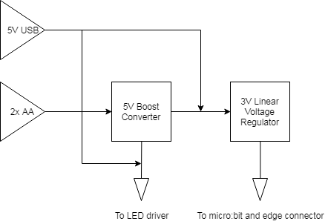

Another idea was to have a switch to choose between power supplies. This avoids the potential danger of having both the USB and batteries connected at the same time.

This has been implemented via a DPDT on-off-on switch. When in position one, the USB is connected directly to the 5V rail of the circuit. When in the middle position, the mega bit is off. When in position 3, the batteries are connected to the input of the Boost converter.

## Expenses and Budgeting

A budget of £500 was received for this project. Therefore, all the components and PCB design choices had to be made to stay within this budget. The following table shows all the expenses incurred for the realisation of the project.

|  |  |  |  |
| --- | --- | --- | --- |
| Item | Quantity | Cost per Item | Total |
| Adafruit 959 Mini 0.7" 8x8 LED Matrix with I2C Backpack Blue | 1 | 10.68 | 10.68 |
| 5601B - Edge Connector Breakout Board Pre-Built, BBC micro:bit, Prototyping Area with 3V/0V Rows | 2 | 4.2 | 8.4 |
| Stripboard Medium 95mm x 127mm | 1 | 1.36 | 1.36 |

**Total Amount Spent: 20.44**

# Meetings and Decisions Taken

## Client meetings:

Meetings were organised with the client to ensure the progress of the project and the decisions made always satisfy the client criteria and do not diverge from the defined project scope.

|  |  |  |  |  |
| --- | --- | --- | --- | --- |
| Meeting No. | Date | Location | Matters Discussed | Decisions Taken |
| 1 | 01/05 | Micro:bit office | -Introduction to the Micro:bit organisation and its activities  -Project description  -Discussion of possible solutions | -I2C probably the best solution but more research needs to be undertaken by the group |
| 2 | 15/05 | Video Call | -Discuss whether to do a large PCB or 3D printed case for mass production  -Hardware design choices from survey (buttons location, LEDs, size, powering options)  -Possible further enhancements: built-in speakers/headphone socket |  |
|  |  |  |  |  |

The aim of the first meeting, held on the 1st of May, was to meet the members of the Micro:bit organisation responsible for the project and further understand the details of the project work. Further to the description of the project, possible solutions for the idea were discussed, i.e. the use of the accessibility pin, I2C bus, and Bluetooth connection. The group undertook thorough research of these possible solutions and I2C proved to be the best solution as it did not affect the functionalities of the other pins.

The second meeting was scheduled on the 15th of May and it was in the form of a video call. The scope of the meeting was to discuss the progress made with the client and ask their advice on the design considerations (location of button, LEDs, size, powering options).

## Supervisor Meetings:

**Meeting 1 (1st of May):** the supervisor attended the meeting with the client at their office

**Meeting 2 (16th of May):** Update on the progress

Discussion about final design: big PCB or 3D printed case

Discussion regarding the powering options (lithium batteries – constraints for shipping, 2AA batteries, USB)

Possibly use I2C to detect when micro: bit is plugged in

Check whether current limiting resistors needed for the matrix before sending off the PCB design

Research more on matrix driver that needs 3V instead of 5V

Consider having colourful LEDs as an addition to the design

## Group Meetings:

Daily meetings were organised within the group to work on the project and meet all the requirements and deadlines. The group was divided into software and hardware subgroups to tackle the tasks more effectively. The former group was in charge of linking the micro:bit to the mega:bit LEDs through I2C verifying that all the functions and sensors would still perform as expected whereas the latter group were involved in designing the product itself including the PCB, decision of components and casing.

|  |  |
| --- | --- |
| Software | Hardware and Research |
| Luke Bussell | Shaun Price |
| Jacopo Carrani | Katarina Boskovic |
| Abhinaya Mathivanan | Afroditi Christodoulou |
|  | Wendy Lu Chen |

Group Organisation:

The group makes use of Microsoft Teams to ensure good communication and effective collaboration. Everyone shares their work through the file-sharing option, so all team members stay up to date. The project deadlines and their requirements are also shared on the platform.

# Documentation of the Code and Materials Used

# Report of Ethical Consequences

The micro:bit has been built to encourage children to learn how to code with its easy and user-friendly interface. After using micro:bit, 90% students now agree that anyone can code. The micro:bit has multiple functionalities (LED screen, sensors, GPIO pins, etc.) which a student can program both freely or aided by multiple libraries available online. In 2016, BBC sponsored free micro:bits for all UK Year 7 students which had a great impact as the interest in coding among Secondary students has not stopped to increase since then. Furthermore, 70% more girls said they would choose Computing as a school subject after using the micro:bit.

The mega:bit is, therefore, an added supplement to encourage this aim. With an 85% increase in demand for computing classes within students after they have used the micro:bit, teachers have faced the difficulty to encourage interaction among the class due to the micro:bit's compact size. Having the mega:bit as a complement teaching tool will help demonstrate individual student's code, increasing the interaction and participation among groups.

As a result, the mega:bit will not only help teachers explain the work of a student more clearly and intuitively but will also boost team work among students. Competitions will be encouraged among subgroups and the outcomes will be shown on the mega:bit to determine the best result. This will make students more competent and willing to work in groups and help each other.

Research findings:

90% of students said the micro:bit showed them that anyone can code.*

86% of students said the micro:bit made Computer Science more interesting.

85% of teachers agree it has made ICT/Computer Science more enjoyable for their students.*

70% more girls said they would choose Computing as a school subject after using the micro:bit*

# Sustainability Report

This product, if successful, is designed to be sent to mass production of around 5000 units. Hence, it is important to keep it as more environmentally-friendly as possible, reducing damaging and unsafe resources. Another point to consider is that this product is aimed for both adults and children use, so electrical protection of the mega:bit itself and the attached micro:bit must be ensured.

* **Power consumption**: to avoid the waste of AA batteries, rechargeable lithium batteries and USB power banks were considered. This would result in more efficient use of the power and avoid non-recyclable batteries.
* **Materials used:** a large scale PCB board would result of copper waste and space unused but it would be more practical for mass production. An alternative would consist of a smaller PCB including only the LEDs inside a 3D printer or acrylic case. This would as well reduce the price of the product.

# Test Results